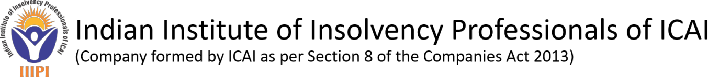

Indian Institute of Insolvency Professionals of ICAI (IIIPI) is a Section 8 Company formed by the Institute of Chartered Accountants of India to enroll and regulate insolvency professionals as its members in accordance with the Insolvency and Bankruptcy Code 2016.
IIIPI invites online application from competent professionals for the following position on contract basis:
Deputy Director-Monitoring & Inspection
Qualification & Experience | An experienced Insolvency Professional (preferably a Chartered Accountant) having 5 years of practical experience in IBC ecosystem with at least 15 years of overall post-qualification experience in the field of Internal/External Audits, Regulatory and Compliance Audits, Systems and Process Audits, Monitoring and Investigations.
Skill Sets required | - Sound knowledge and practical exposure of Insolvency and Bankruptcy Code 2016, Rules, Regulations and Guidelines.  - Good interpersonal skills.  - Effective written and verbal communication skills
Job Profile | - To carry out regular monitoring of professional members including compliance checks for issuance/renewals of AFA to IPs and IPEs  - To conduct Inspections/Investigations, in accordance with Monitoring/Inspection Policy  - To update the Monitoring Policy, Inspection policy and Manual of IIIPI on regular basis  - To coordinate with IBBI and other IPAs for pursuing a common approach and assessment/rating model for the inspection  - To conduct meetings of Monitoring Committee in accordance with the policy from time to time  - To prepare a report of monitoring, Inspection/Investigation(s) as per the Monitoring Policy, Inspection Policy and submit the same to the Monitoring Committee  - To handle other tasks assigned by the IIIPI/Committee/Managing Director from time to time.
Administrative | - To oversee all administrative and operational functions performed in the Department  - To exhibit leadership skills in steering the team effort towards abovesaid functions
Compliance | - To verify compliance with the provisions of the Code, rules, regulations, guidelines and directions issued by the Committee/ Board in undertaking Monitoring, Inspections/Investigations
Age | - 40 – 45 Years as on 30th June 2026
Nature of Employment | - On Contract basis for a period of three years renewable thereafter based on the performance
Annual CTC | - Up to Rs. 25 lakhs approx.

Note- The Parameters as mentioned above may be relaxed in case of deserving candidates as per the discretion of IIIPI.
Download Application Form
Eligible persons can submit their online applications through E-Mail along with copy of relevant certificates in respect of qualification and experience in the given format to:
Managing Director,
Indian Institute of Insolvency Professionals of ICAI,
E-Mail: ip_recruitment@icai.in
Last Date for Submission of application: July 20, 2026.

